**COME 373 LAB PROJECT HOMEWORK**

**WEB SITE DESIGN AND BASIC STRUCTURE CREATION**

**1. Home Page**

Title: "WebDevEdu: Your Gateway to Web Development Learning"

Concept: Introducing the platform as a hub for web development education, offering courses, resources, and a supportive community.

**2. Navigation Menu**

Home

Courses

Blog

**3. Content Pages**

Home Page (index.html)

Welcome message

Brief overview of course offerings

Call-to-action buttons for exploring courses

Courses Page (courses.html)

List of available courses with brief descriptions

Call-to-action buttons for enrolling

Blog Page (blog.html)

Latest blog posts with summaries

Links to read more

**4. Links and External Sources**

Included a link to an external resource like MDN Web Docs or a prominent web development blog with a brief description.

**5. Visual Content**

Used images related to web development on various pages.

Ensured all images have descriptive alt texts for accessibility.

**6. Form Elements**

Created a basic contact form with fields for first name, last name, and email.

Included a submit button.

**7. CSS Design**

Styled elements for a clean and professional look: fonts, colors, backgrounds, buttons, and navigation bar.

**8. Page Layout and Organization**

Organized content with clear headings, subheadings, and paragraphs.

Ensure a consistent layout and design across all pages for a cohesive user experience.

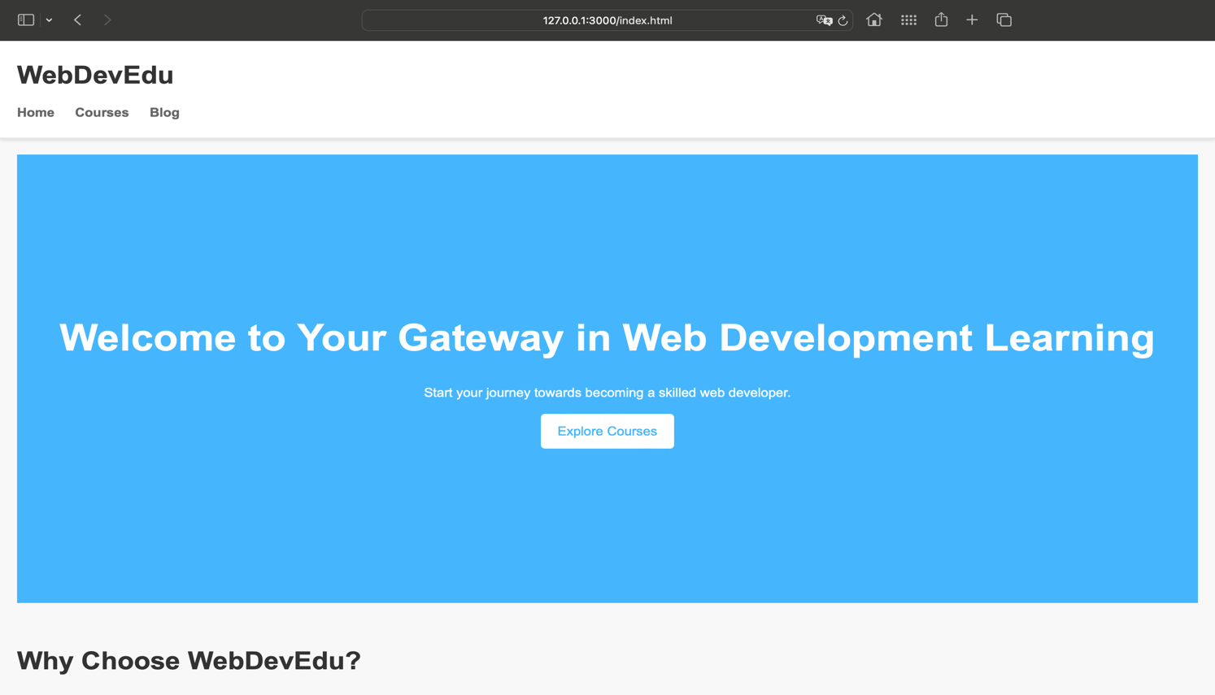

metin, yazılım, web sayfası, web sitesi içeren bir resim

Açıklama otomatik olarak oluşturuldu

metin, ekran görüntüsü, yazılım, web sitesi içeren bir resim

Açıklama otomatik olarak oluşturuldumetin, yazılım, ekran görüntüsü, web sayfası içeren bir resim

Açıklama otomatik olarak oluşturuldumetin, yazılım, ekran görüntüsü, bilgisayar simgesi içeren bir resim

Açıklama otomatik olarak oluşturuldu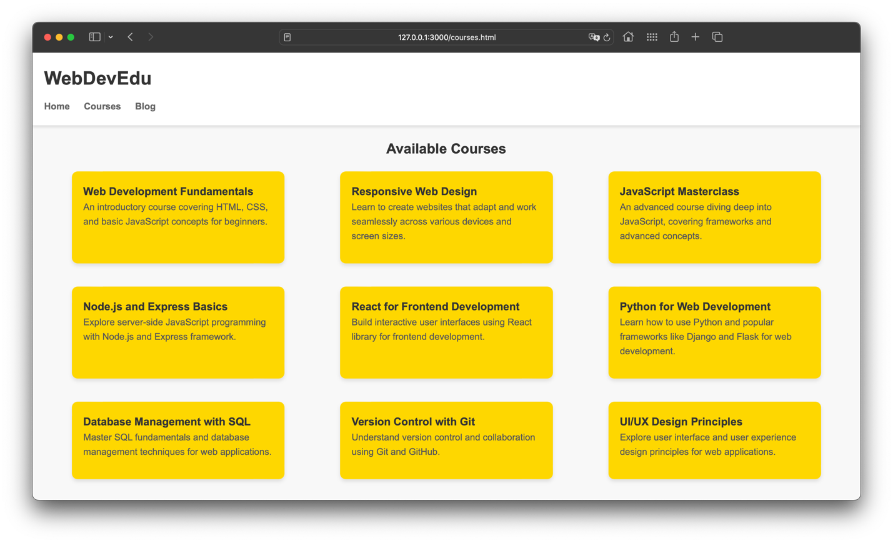metin, ekran görüntüsü, yazılım, web sitesi içeren bir resim

Açıklama otomatik olarak oluşturuldu

**20190301036**

**Bekir Enes ŞİRANLI**